

**Networking & IT Infrastructure**

**Assignment**

**IP Subnetting Proposal**

Submitted by

**SIM YIZHUN | S10251450**

**CURLYNN TAN | S10251463**

**DARYL GOH DA HUI | S10251448**

**YANN NGEW | S10251461**

of TEAM 01

The pages of this proposal omits the cover page and Table of Contents.

Proposal Page Count: **20**

Table of Contents

1.0 Background 1

2.0 Introduction 1

3.0 Network Needs Analysis 1

4.1 The Design and Selection 2

4.2 The Proposed Scalable IP Addressing Scheme For YDC Interior 3

4.3 Subnet IP Address Range 3

4.4 Network Capacity, Bandwidth and Estimated Users 3

4.5 Server Components 4

**4.5.1 File Server** 4

**4.5.2 Web Server** 4

5.0 IP Address Assignments 4

5.1 Assignments to Appropriate Devices, Router, Switches and End Devices 4

**5.1.1 Step 1.1 IP Address Assignments to Network B - 1st Subnet** 4

**5.1.2 Step 1.2 IP Address Assignments to Network E (Design Department) - 2nd Subnet** 5

**5.1.3 Step 1.3 IP Address Assignments to Network A - 3rd Subnet** 7

**5.1.4 Step 1.4 IP Address Assignments to Network D - 4th Subnet** 8

**5.1.5 Step 1.5 Assigning 5th Subnet To Sales Department** 9

5.2 Network Addresses, VLANs, Routing Configurations On Networking Devices 11

5.2.1 Final Addressing Table 11

6.0 Enhancements 11

6.1 Enhancement I: Secure Socket Shell 11

6.2 Enhancement II : ACL 12

7.0 Budget Estimate 12

7.1 Cost Benefit Analysis (CBA) 12

7.2 Benefit Analysis 13

7.3 Cost-Benefit Ratio 13

8.0 Conclusion 14

9.0 References 15

10.0 Appendices 15

10.1 Appendix A: Members & Contributions 15

10.2 Appendix B: Packet Tracer Documentation 15

# **1.0 Background**

Our team created this proposal report as part of our module assignment: Networking IT & Infrastructure. This assignment aims to develop a secure networking system that would reduce the risk of cyber-attacks and data theft.

# **2.0 Introduction**

This proposal is for a data communication network to serve a small start-up Interior Design Firm - **YDC Interior**. With collaborations with lead generation companies, the firm intends to upscale on a progressive rate of 15% per annum quarter. Thus, extensive planning should go into a network installation or implementation. As with any project, a need is identified thus, this proposal outlines the steps (or phases) of a structured network design and demonstrates a practical implementation of the steps through Cisco Packet Tracer™ software.

# **3.0 Network Needs Analysis**

The basis for the Network Needs Analysis is based on the extended knowledge that the network system is for an Interior Design company in its early stages of operations. Thereby, the analysis is focused on the core of the firm that essentially needs connectivity to carry daily operational tasks.

|  |  |  |
| --- | --- | --- |
| **S/No** | **Requirement(s)** | **Client’s Response** |
| **1** | 1. Number of Users 2. Type of Equipment | 1. Accounting Team - 2 Personnel 2. Design Team - 2 Personnel 3. Sales Team - 2 Personnel |
| **2** | Service Provider Equipment | Fast and Stable |
| **3** | Number of Printer(s) | None. Concrete Plans to acquire one for the Sales Team. |
| **4** | Reliability and Uptime Expectations | Reliable and consistent network |
| **5** | Security & Privacy Concerns | Secured with restricted access; ability to filter. |
| **6** | Physical Layout | Unavailable. |
| **7** | Application Requirements | 365 MSOffice, AutoCAD, 3DMax, Adobe Photoshop, Adobe Illustrator, Sketchup Pro, 1SalesForce Sales Cloud, Wrike, Xero. |
| **8** | Budget Estimate | Value-for-money; Estimated Budget of SGD30,000-40,000/- |
| **9** | Project Growth | Number of users and departments will increase overtime. |

Figure Table of Requirements

The requirements are narrowed down based on the Figure 1.0 (as shown above) and it is as follows-:

**3.1 Functionality**

At present, there is no existence of a network system in place, thus, there would be no consideration to input existing devices and integrate with a former network system. The design of the network is to be functionally and physically isolated from access by people not employed by **YDC Interior** so as to minimize the risk of unauthorized use. The integration and updates are to be effortless and versatile, one that enables users to retrieve, process and store ASCII and non-ASCII text, different media mediums from any connected computer and across all existing departments.

**3.2** **Network Scalability**

The design should be scalable so more departments and devices can be added as the business expands without having to redo the installed network while combining the power and capabilities of diverse equipment across the office space to provide a collaborative medium that aids in sharing information and ideas easily, so as to work in a more efficient and productive manner.

**3.3 Intended Users**

The intended primary users of the network are the sales, accounting and design team of **YDC Interior**, with two users per department as of current. With higher sales volume and project completion turnover rates, LANS and WAN are expected to operate at 99.9% uptime and undiscovered error rate of .01%, in alignment with user expectations and industry standards.

**4.0 The Network Diagram Design**

The focus on this project is placed on its data flow, data types, and processes that access or change the data while being scalable. As a floor plan is currently not obtainable, a site survey and diagram of the floor plan will be required to indicate size and locations of working spaces.

## **4.1 The Design and Selection**

Figure Design of The Network Diagram simulated on Packet Tracer

The main goal of the project at its initial stages is to design it in a manageable way while taking under serious consideration that it may be easily modified and maintained with ease, thus, creating value of convenience and efficacy. By using the Packet Tracer simulation, it allows one to view the LAN from a documentation perspective and be able to evaluate trade-offs in performance and cost. During the designing phase of the network, weaknesses of the design may be identified and addressed.

In Figure 2, the design of the structural network diagram consists of the two 2911 Router(s), five 2960 Switches, two Server components - a Web Server and File Server; two laptops; four PCs, and one printer allocated to the Sales Team. This is achieved by using the modular concept and dividing it into three prominent networks as per team. Upon approval of this project, a successful prototype is a good indicator of how the network will eventually operate.

## **4.2 The Proposed Scalable IP Addressing Scheme For YDC Interior**

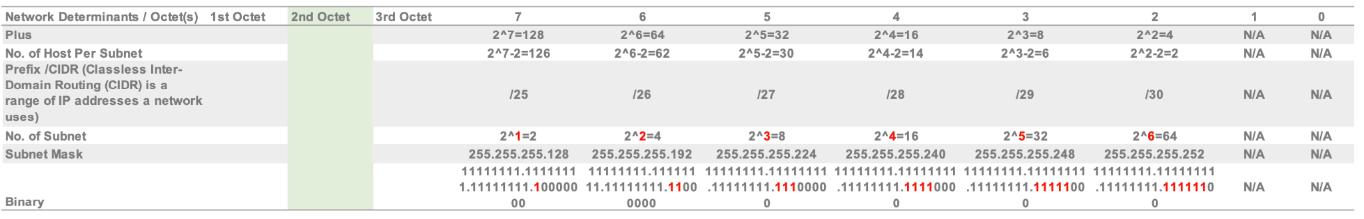Figure 3.0 depicts the proposed scalable IP Addressing Scheme for YDC Interior with the network determinants calculated as follows-:

Figure 3 Network Determinants Calculation Table

## **4.3 Subnet IP Address Range**

Figure 4 Table For Network Device Components

The Base Network Address is **200.10.1.0/24**. As shown in Figure 4.0, the range of Subnet IP Addresses are from the 1st IP to the Last Addresses, as shown in Figure 4.

## **4.4 Network Capacity, Bandwidth and Estimated Users**

The transmission speed should be transparent to users, in order for remotely executed applications, file transfers and the like to ideally appear to operate as quickly as processes executed within an end-station. To ascertain the intended users’ needs and expectations, using the capabilities of Fast Ethernet and Gigabit Ethernet connectivity.

The bandwidth of the physical interface will be able to support delivery of speeds from 10/100 megabits per second (Mbps) within each internal LAN and 1000 Mbps bandwidth between external LANs respectively. If required, more support will be allocated than needed performance in most cases. This may include activities such as frequent video conferencing and large file sharing to be hindered between departments and their clients.

As depicted in Figure 4, the maximum users hosted on Network E (Design Department) is 30; the maximum users on Network D (Accounting Department) is 30, and Network F (Sales Department) may host a maximum of 14 users.

## **4.5 Server Components**

### **4.5.1 File Server**

The File Server’s accessibility caters to the three departments of YDC Interior - Accounting, Design, Sales, to facilitate effective and efficient file sharing, data management, project management across teams or departments.

### **4.5.2 Web Server**

To limit public traffic into the firm’s internal file storage systems, the accessibility of Web Server is denied from the File Server.

# **5.0 IP Address Assignments**

This section illustrates the steps taken to achieve the final addressing table (as shown in Section 5.2.1), which consists of the devices and its respective IP Addresses, Sub-masks, Default Gateway and designated interfaces. The documentation of the Packet Tracer implementation process is attached as Appendix B ,for clearer reference.

## **5.1 Assignments to Appropriate Devices, Router, Switches and End Devices**

### **5.1.1 Step 1.1 IP Address Assignments to Network B - 1st Subnet**

The steps of IP Address assigned to Network B as the first Subnet is as follows-:

1. 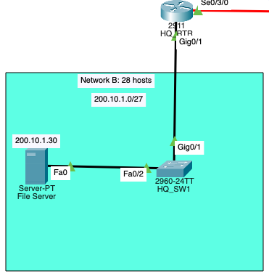Use the first host address for the **HQ_RTR interface** connected to **HQ_SW1 switch, to assign the first Subnet to Network B**
2. Use the second host address for the **HQ_SW1 switch** and assign a default gateway address for the **switch**.
3. Use the last host address for **File Server (FTP Server)** and assign a default gateway address for the **Web Server**.

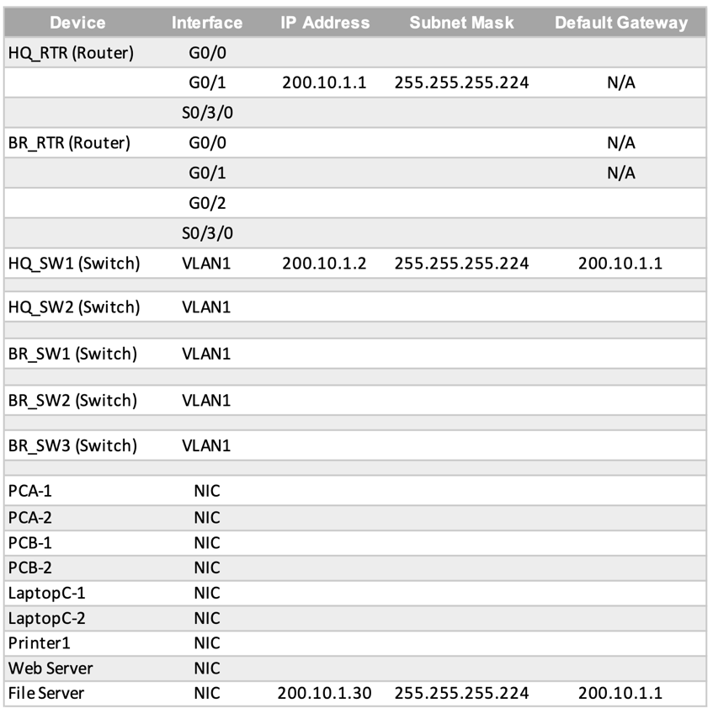**Addressing Table for First Subnet Assigned To Network B**

Figure 5 Addressing Table: First Subnet To Network B

The addressing table depicts the IP addresses, subnet masks and default gateways achieved from assigning the first subnet to Network B.

### **5.1.2 Step 1.2 IP Address Assignments to Network E (Design Department) - 2nd Subnet**

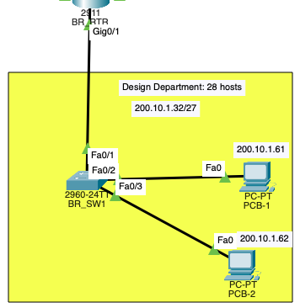

The steps of IP Address assigned to Network E (Design Team) is as follows-:

1. Use the first host address for the **BR_RTR interface** connected to **BR_SW1 switch.**
2. Use the second host address for the **BR_SW1 switch** and assign a default gateway address for the **BR_SW1** **switch** at this stage.
3. Use the last host address for **PC-B1** and assign a default gateway address for the **PC-B2**.

**Addressing Table For Second Subnet Assigned To Network E**

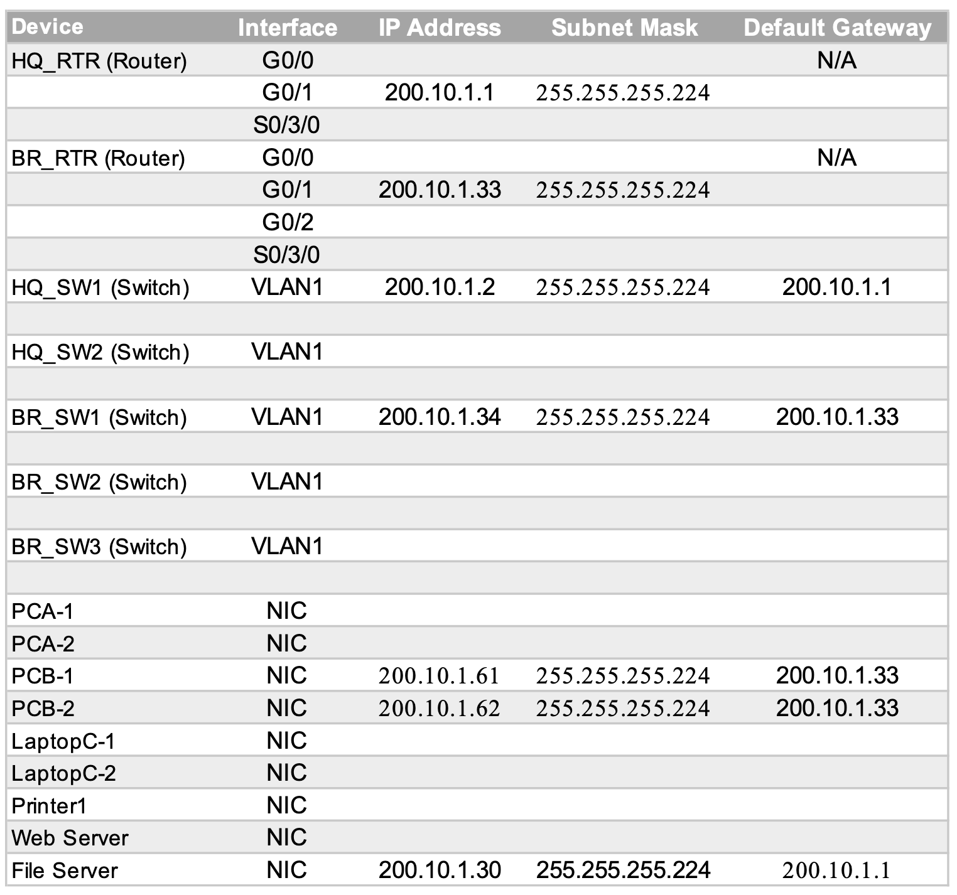

Figure 6 Addressing Table For Second Subnet Assigned To Network E

The addressing table in Figure 6 depicts the IP addresses, subnet masks and default gateways achieved from assigning the second subnet to Network E.

### **5.1.3 Step 1.3 IP Address Assignments to Network A - 3rd Subnet**

The steps of IP Address assigned to Network A as the third Subnet is as follows-:

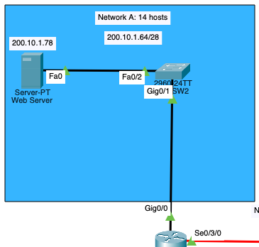

1. Use the first host address for the **HQ_RTR interface** connected to **HQ_SW2 switch.**
2. Use the second host address for the **HQ_SW2 switch** and assign a default gateway address for the **HQ_SW2** **switch**.
3. Use the last host address and assign a default gateway address for **Web Server**.

**Addressing Table for Network A**

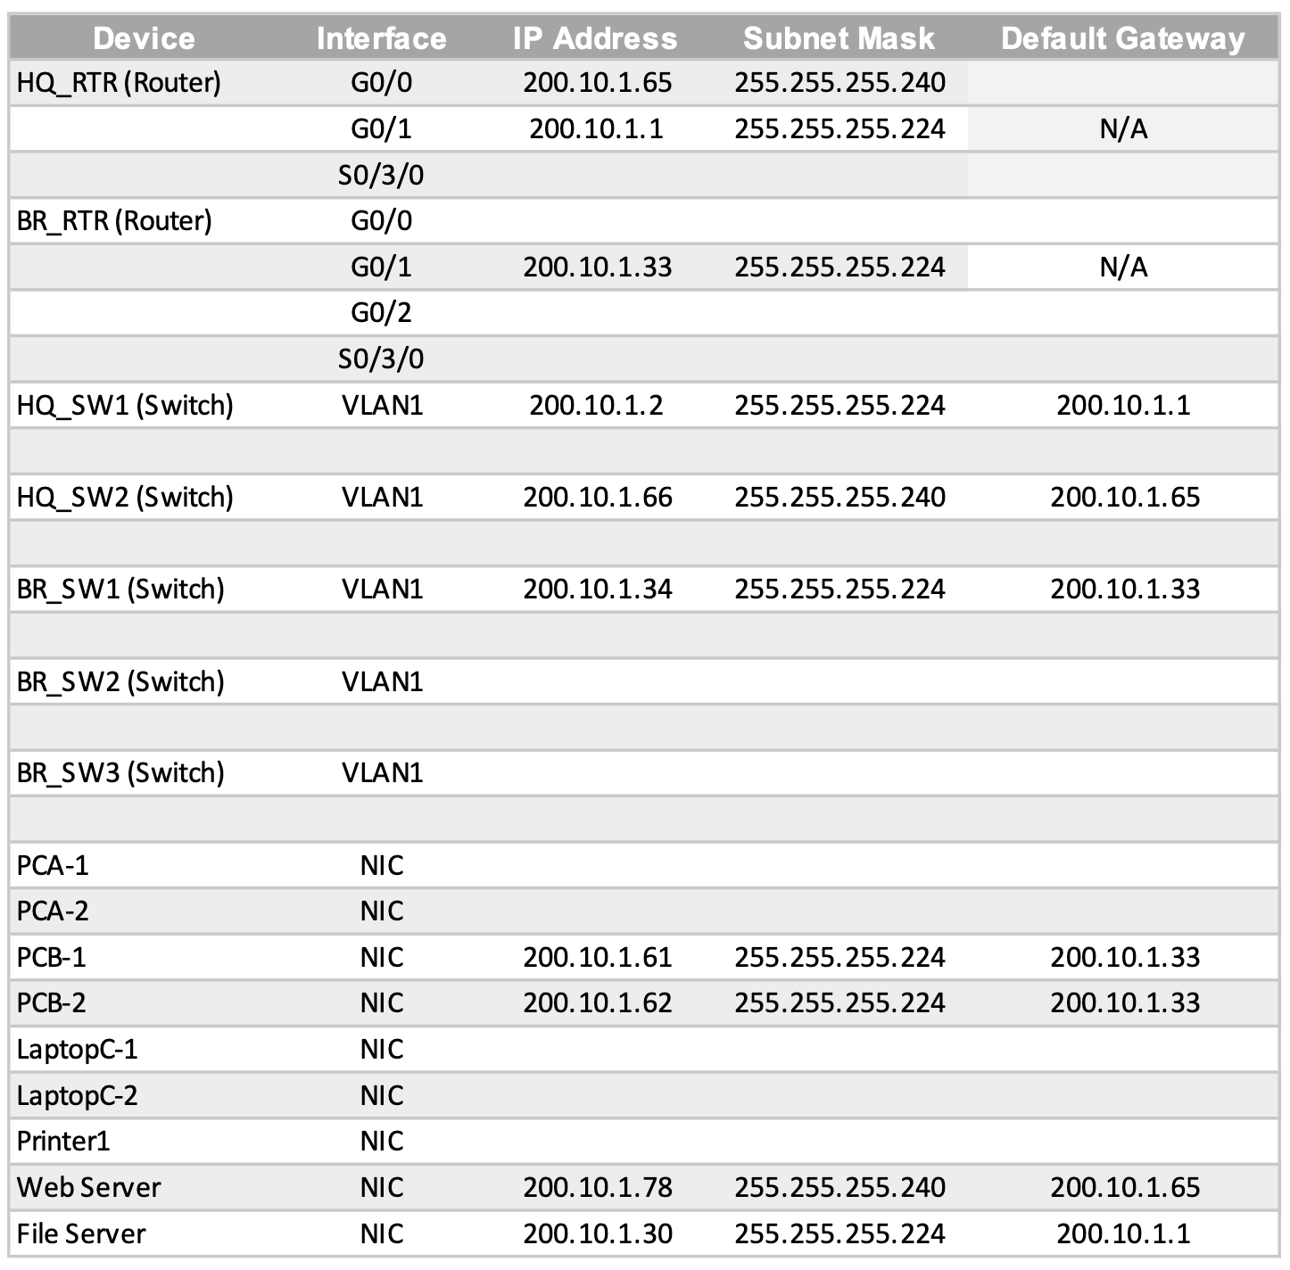

Figure 7 Addressing Table For Assigning Third Subnet To Network A

The addressing table depicts the IP addresses, subnet masks and default gateways achieved from assigning the third subnet to Network A.

### **5.1.4 Step 1.4 IP Address Assignments to Network D - 4th Subnet**

The steps of IP Address assigned to Network D as the fourth Subnet is as follows-:

1. 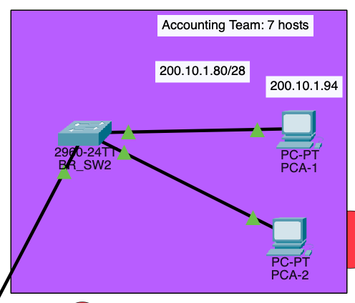Use the first host address for the **BR_RTR interface** connected to **BR_SW2 switch**
2. Use the second host address and assign a default gateway address for the **BR_SW2 switch**.
3. Use the second last host address and assign a default gateway address for **PC-A1** and **PC-A2**.

**Addressing Table For Assignment of 4th Subnet to Network D**

The addressing table depicts the IP addresses, subnet masks and default gateways achieved from assigning the forth subnet to Network D.

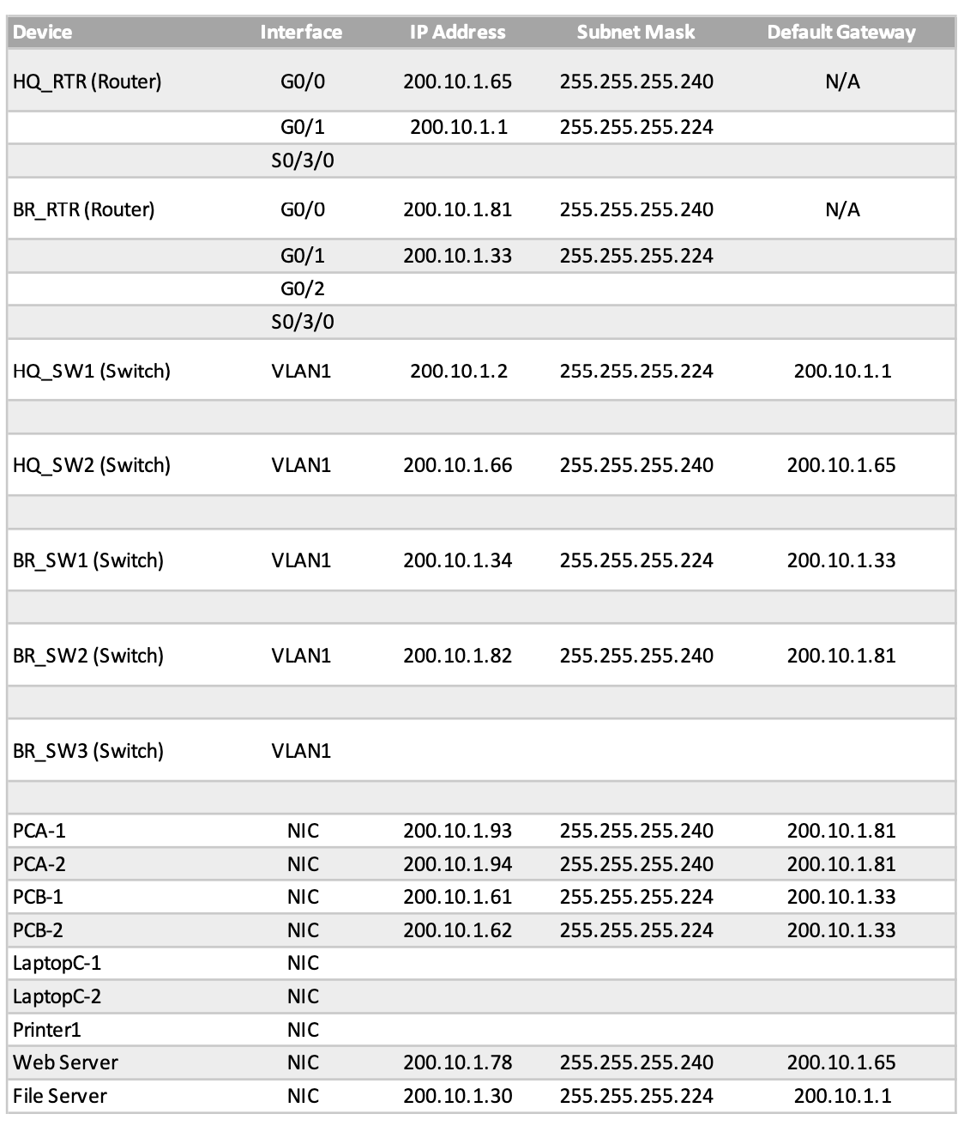

Figure Addressing Table For Assignment of Forth Subnet To Network D

### **5.1.5 Step 1.5 Assigning 5th Subnet To Sales Department**

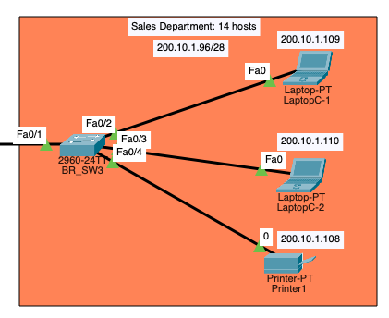

The steps to implementing the assignment of the fifth subnet to the Sales Department is as follows-:

1. Use the first host address for the **BR_RTR interface** connected to **BR_SW3 switch**
2. Use the second host address and assign a default gateway address for the **BR_SW3 switch**.
3. Use the third last host address for **Printer1**.
4. Use the second last host address for **Laptop-C1.**
5. Use the second last host address for **Laptop-C2.**
6. Assign a default gateway address for **PC-A1** and **PC-A2**.

**Addressing Table for Subnet Setup of Sales Department**

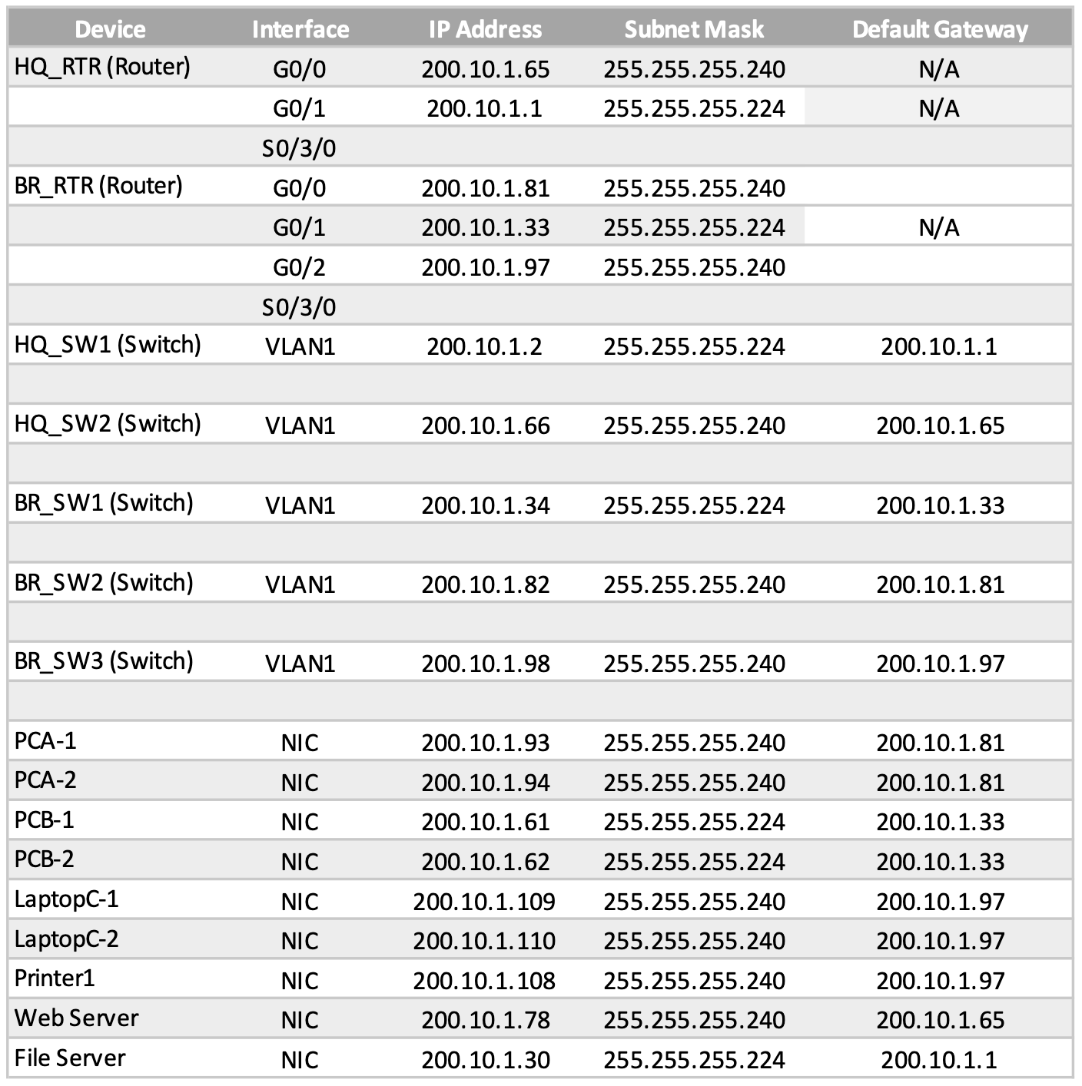

Figure 9 Addressing Table For Fifth Subnet to Sales Department

The addressing table depicts the IP addresses, subnet masks and default gateways achieved from assigning the fifth subnet to the designated network of the Sales Department.

**5.1.6 Step 1.6 Assigning 6th Subnet To Network C**

The steps to assigning the sixth subnet to Network C is as follows-:

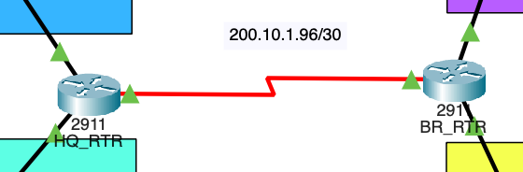

1. Use the first host address for the **HQ_RTR interface** connected to **BR_RTR.**
2. Use the last host address for the **BR_RTR to HQ_RTR.**

**Addressing Table for Network C**

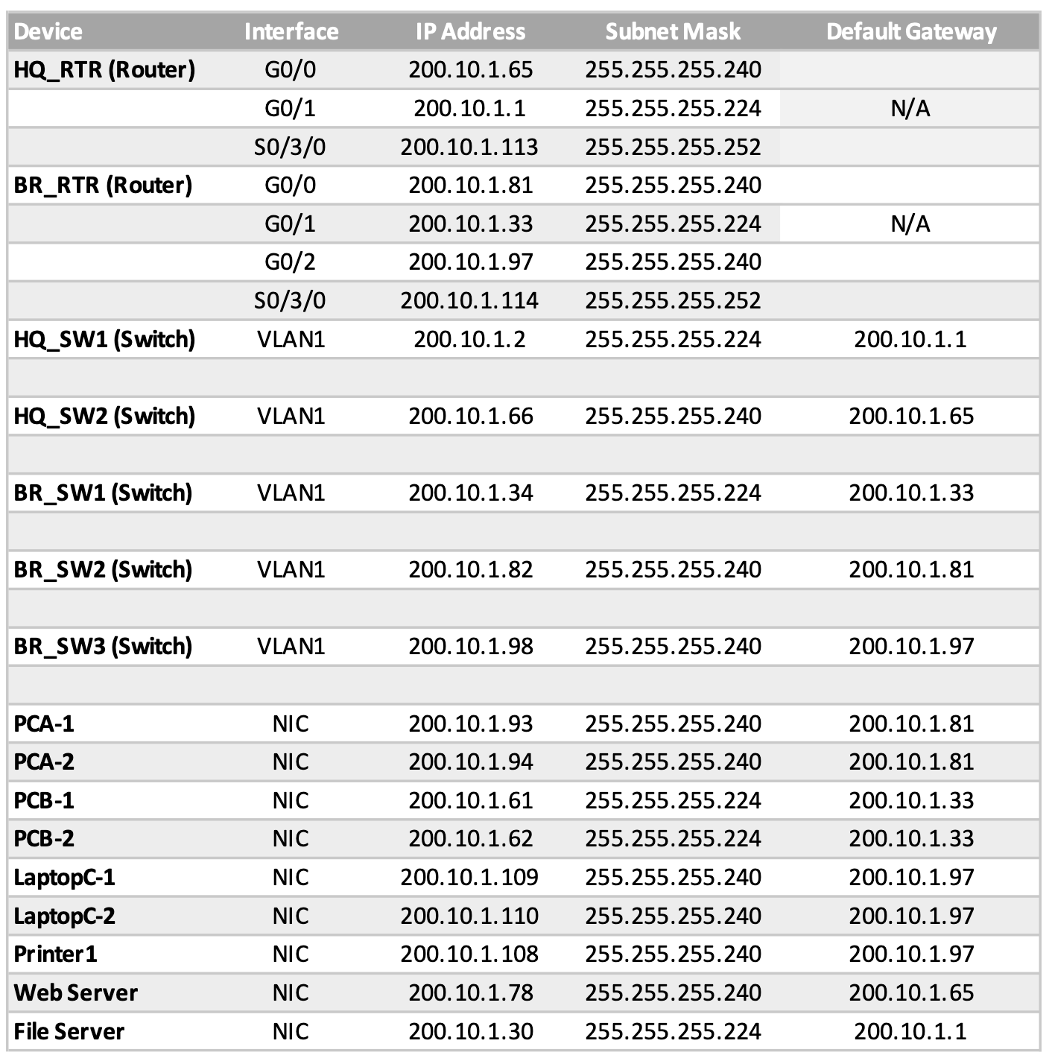The addressing table depicts the IP addresses, subnet masks and default gateways achieved from assigning the sixth subnet to Network C.

Figure 10 Addressing Table For Assigning Sixth Subnet To Network C

## **5.2 Network Addresses, VLANs, Routing Configurations On Networking Devices**

## **5.2.1 Final Addressing Table**

Figure Final Addressing Table

Figure 11 depicts that the finalization of Step 1.1 – 1.6 of the IP Addresses Assignments.

# **6.0 Enhancements**

This network design includes Secure Socket Shell (SSH) and ACL additions to the structure network design.

## **6.1 Enhancement I: Secure Socket Shell**

The setup of SSH network communication protocol is enabled in the network design to secure remote login from one computer to another, SSH-5, SSH 1.99 is significant for YDC Interior as the firm requires back and forth file transferring while containing sensitive client data. This is done by implementing a username/password authentication system to establish a secure connection.

Key-name: HQ_Rtr.ccna-lab.com

## **6.2 Enhancement II : ACL**

In this proposal, standard ACLs are being utilized. It provides a basic auto-filter and aid in limiting network traffic to increase network performance, control traffic flow, and provide basic level of security for network access within the radius of the working space. It also enables hosts to permit or deny access to network services and prioritize certain classes of network traffic.

An ACL allows YDC Interior to prevent intentional or unintentional data loss or data exfiltration. This reduces any form of risks of reputational damages to the brand, or loss of customers and revenue.

# **7.0 Budget Estimate**

The Cost Benefit Analysis (CBA) is used to determine if the benefits to be gained outweigh the costs (Hayes, 2021). Devices and cabling are selected based on the brief requirements outlined. The key measures in choosing the devices and cabling for a structural network system are cost, number of ports, speed, expandability and manageability.

## **7.1 Cost Benefit Analysis (CBA)**

|  |  |  |  |
| --- | --- | --- | --- |
| **Cost Analysis** | | | |
| **Tangible Costs** | | | |
| **Product** | **Price** | **Quantity** | **Total** |
| **2911 Router** | **$2,500** | **2** | **$5,000** |
| **2960 Switches** | **$3,000** | **4** | **$12,000** |
| **PC(s)** | **$2,000** | **4** | **$8,000** |
| **Laptop** | **$3,000** | **2** | **$6,000** |
| **Web Server** | **$8,000** | **1** | **$8,000** |
| **File Server** | **$5,000** | **1** | **$5,000** |
| **Printer** | **$1,100** | **1** | **$1,100** |
| **Subtotal of Tangible Costs** | | | **$45,100** |
| **Intangible Costs** | | | |
| **Product** | **Price** | **Quantity** | **Total** |
| **Network Down Time**  (Estimated at 12 hrs/yr) | **$3,000.00** | **1** | **$3,000** |
| **Subtotal of Intangible Costs** | | | **$3,000** |
| **Total 3-year Cost Analysis** | | | **$144,300** |
| **Total Annualized Cost** | | | **$48,100** |

## **7.2 Benefit Analysis**

| **Benefit Analysis** | | |
| --- | --- | --- |
| **Products** | **Price** | |
| **Increased Productivity** | **$25,000 / yr** | |
| **Decreased Anxiety (from increased reliability)** | **$4,000 / yr** | |
| **Ease of Record Keeping** (i.e. fewer lost files and faster availability) | **$25,000 / yr** | |
| **Increased Security** | **$25,000 / yr** | |
| **Increased Staff Morale** | **$15,000 / yr** | |
| **Intangible Benefits** | | |
| **Increased Staff Morale** | **$15,000 / yr** | |
| **Increased Brand Reputation** | **$25,000 / yr** | |
| **Total Benefit Analysis =** | | **$134,000/year** |

## **7.3 Cost-Benefit Ratio**

|  |  |  |
| --- | --- | --- |
| **Cost-Benefit Ratio Table** | | |
| **Total Cost** | **Total Benefit** | **Ratio** |
| **$48,100/year** | **$134,000/year** | **0.35**  (rounded up to next decimal point) |

As calculated in the Cost Benefit Ratio Table, the annual benefit exceeds the annualized cost where the project is expected to pay for itself in 12 months. The projected time to functional obsolescence of equipment is estimated at about 36 months. If the Benefit Cost Ratio (BCR) value is less than 1, then the project cost can be expected to be higher than the returns, and therefore, it should be discarded (Weller, 2016). It is to be noted that the values of intangibles are subjected to interpretation, to which the values of the products and benefits are averaged and accurate at the time this proposal was written.

Given the results shown, it is therefore recommended that the project is essential to implement for higher productivity and efficiency within a progressively growing corporate structure.

# **8.0 Conclusion**

To increase accuracy in this proposal, YDC Interior’s business processes should be discussed in greater detail.

The CBA does not include the realistic wiring blueprint of the office space. As such, where a floor plan is currently not obtainable, a site survey and diagram of the floor plan will be required to indicate size and locations of working spaces. It is ideal to make measurements on how cables should be run best and be aware of structural buildings that may affect latency and connectivity. Upon approval of the network design with possible device add-ons, the implementation of the network may then commence.

As part of the requirement discovery and with a higher budget, it is suggested that the network can be built in phases per ¾ of a year. Hence, it does not restrict a Two-tier FTP system, where an administrative tier gain full access to the servers, while the teams have limited access but are still able to access necessary across departments.

# **9.0 References**

References are cited according to APA styling format.

Weller, J. (2016, December 8). *Cost Benefit Analysis: An Expert Guide | Smartsheet*. Smartsheet. <https://www.smartsheet.com/expert-guide-cost-benefit-analysis>

Hayes, A. (2021, August) *Cost-benefit analysis*. Investopedia. <https://www.investopedia.com/terms/c/cost-benefitanalysis.asp>

# **10.0 Appendices**

## **10.1 Appendix A: Members & Contributions**

|  |  |  |
| --- | --- | --- |
| **#** | **Name of Member(s)** | **Contributions** |
| **1** | **Sim Yizhun** | * **Packet Tracer Building** * **Structural Design of Network** * **Presentation Creation** |
| **2** | **Daryl Goh Da Hui** | * **Packet Tracer Building** * **Enhancement Building** * **Presentation Creation** |
| **3** | **Curlynn Tan** | * **Presentation Creation** * **Proposal Creation** * **Documentation Creation & Compilation** |
| **4** | **Yann Ngew** | * **Presentation Creation** * **Proposal Creation** * **Documentation Creation & Compilation** |

## **10.2 Appendix B: Packet Tracer Documentation**

The Excel Spreadsheet labeled as **<Network and IT Infrastructure Assignment>** is provided in the Team01-Submission Folder, for clearer referencing purposes.



